**Creating a GitHub Account & Introducing GitHub**

* GitHub is a popular version control system specifically designed for collaborating on code projects.
* To use GitHub, you'll need to create a free account at <https://github.com/Index>. This account allows you to create and manage your own repositories (code storage locations) and collaborate with others.

**Creating a Remote Repository**

* A remote repository is a code repository that resides on GitHub's servers, accessible from anywhere with an internet connection.
* Once you're logged in to GitHub, you can create a new repository by clicking the "New repository" button and providing a name and (optionally) a description.
* This creates an empty repository on GitHub, ready to be populated with your code.

**Connecting Local & Remote Repositories**

* To connect your local code project (where you're writing code) to your remote repository, you'll use Git, a version control system.
  + If you haven't already, download and install Git from <https://git-scm.com/downloads>.
* Initialize a Git repository in your local project directory using the git init command.
* Add the remote repository URL (found on your GitHub repository's "Settings" page) to your local Git repository using the git remote add origin <remote_url> command, where <remote_url> is the copied URL.
* Now, your local project and the remote repository are connected.

**Understanding the Personal Access Token**

* A personal access token (PAT) is a secure way to authenticate with GitHub from the command line or other tools without revealing your password.
* You can create a PAT from your GitHub account settings under "Security" > "Developer settings" > "Personal access tokens".
* Choose a descriptive name for your token and grant it the necessary permissions (e.g., "repo" for full repository access).
* **Important:** Treat your PAT like a password and keep it confidential.

**Pushing a Second Commit**

* After making changes to your code, you'll want to track those changes using Git.
* Stage the changes you want to commit using git add <filename>.
* Create a commit message using git commit -m "<message>" to describe the changes.
* Now, to push your local commits to the remote repository on GitHub, use git push origin <branch_name>. Replace <branch_name> with the name of the branch you want to push to (usually master for the main codebase).

**From Local to Remote - Understanding the Workflow**

1. **Local Development:** You make changes to your code in your local project directory.
2. **Staging:** You use git add to tell Git which changes you want to include in the next commit.
3. **Committing:** Use git commit to create a snapshot of your code with a descriptive message.
4. **Pushing:** Use git push to send your local commits to the remote repository on GitHub.

**Remote Tracking Branches in Practice**

* When you push a local branch to a remote repository for the first time, a corresponding remote tracking branch is created automatically on GitHub.
* These remote tracking branches keep track of the remote branches on GitHub that your local branches are following.
* You can use git branch -vv to view your local branches and their associated remote tracking branches.

**Understanding Local Tracking Branches**

* A local tracking branch is a local branch that is "linked" to a remote tracking branch.
* This link helps you keep your local development in sync with the remote repository.
* When you use git push, you're typically pushing to the remote branch that your local tracking branch is linked to.

**Creating Local Tracking Branches**

There are two main ways to create a local tracking branch:

1. **Pushing a new local branch:** When you push a local branch that doesn't yet exist on GitHub, a remote tracking branch is created automatically.
2. **Specifying the remote tracking branch:** Use git branch --track <local_branch_name> <remote_url>/<remote_branch_name> to create a local tracking branch linked to a specific remote branch.

**Remote & Tracking Branches - Command Overview**

Here are some common Git commands related to remote and tracking branches:

* git remote add <remote_name> <remote_url>: Add a remote repository (e.g., git remote add origin https://github.com/your_username/your_repo.git).
* git remote -v: View configured remote repositories.
* git branch -vv: List local branches and their associated remote tracking branches.
* git push origin <branch_name>: Push

**Cloning a Remote Repository**

* **Getting a Copy of a Remote Repository:** Cloning is like making a copy of an existing remote repository on GitHub. This creates a complete replica of the code and history on your local machine.
* **The git clone Command:** To clone a repository, open your terminal or command prompt and navigate to the directory where you want the local copy. Then, use the command git clone <remote_url>, replacing <remote_url> with the URL of the repository you want to clone (usually found on the GitHub repository's main page).
* **Now You Have a Local Copy:** Once you run the git clone command, Git downloads the entire repository and creates a local copy on your machine. This allows you to work on the code offline and make changes without affecting the original remote repository.

**Deleting Remote Branches & Public Commits (Proceed with Caution)**

* **Be Careful!:** Deleting remote branches and public commits is a permanent action. Once you remove something, it's generally gone for good. It's important to understand the consequences before proceeding.
* **Deleting Remote Branches:** If you've created a remote branch on GitHub that you no longer need, you can delete it using the GitHub web interface or the command line. However, proceed with caution! Deleting a branch removes all the commits associated with it.
  + **On GitHub:** Navigate to your repository on GitHub, go to "Settings" > "Branches". Find the branch you want to delete and click the "Delete branch" button.
  + **Using Command Line:** With proper authentication (like a PAT), you can use the git push origin --delete <branch_name> command to delete the remote branch.
* **Deleting Public Commits (Very Difficult):** Unfortunately, deleting public commits from a remote repository on GitHub is extremely difficult and generally not recommended. The Git version control system is designed to be tamper-proof, so once a commit is pushed, it's almost impossible to completely remove it. However, you can contact GitHub support for exceptional circumstances.

**Understanding GitHub Use Cases**

GitHub offers a variety of functionalities depending on your needs. Here's a breakdown of some common use cases:

**1. Understanding GitHub Account Types:**

There are two main account types on GitHub:

* **Free Account:** This is the most common type, offering basic features like creating public repositories (visible to everyone), collaborating on public repositories, and using some limited automation features.
* **Paid Account (Individual or Organization):** Paid accounts offer additional benefits, such as creating private repositories (only accessible to authorized users), increased storage space, more advanced collaboration features, and access to additional tools and features.

**2. Changing Repository Type (Public to Private):**

* **Making Your Code Private:** If you're working on a personal project or something confidential, you can choose to make your repository private. This restricts access to only those you invite as collaborators.
* **Switching Types:** To change your repository type from public to private, navigate to your repository's settings on GitHub. There should be an option to change the visibility settings.

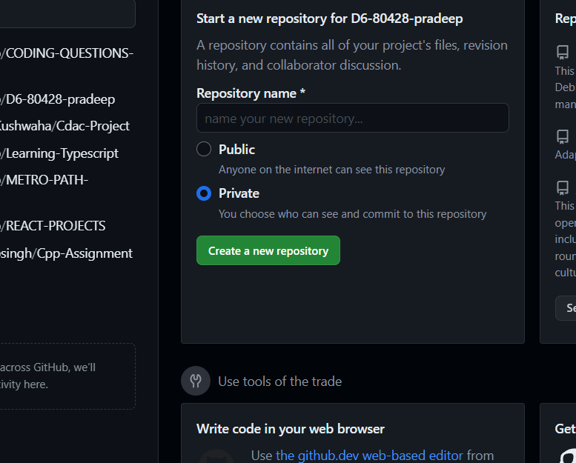



**3. Pushing Commits to a Public Repository:**

* **Sharing Your Work:** Once you've connected your local project to a remote repository (public or private), you can use git push commands to send your local code changes (commits) to the remote repository on GitHub.
* **Public Repositories and Visibility:** Remember, anything pushed to a public repository is visible to everyone on the internet. Make sure you're comfortable sharing the code before pushing.

**4. GitHub Account Security:**

* **Keeping Your Account Safe:** GitHub takes security seriously. They offer features like two-factor authentication (2FA) and personal access tokens (PATs) to enhance account security.
* **Understanding Security Measures:** It's crucial to enable 2FA and use strong passwords to protect your account. Use PATs cautiously, granting only the necessary permissions to specific tools or applications.

**5. Adding Collaborators (Private Repositories):**

* **Working Together on Private Projects:** Private repositories allow you to collaborate with others on your code. You can invite specific users as collaborators, granting them access to the codebase.
* **The Invitation Process:** To add a collaborator, navigate to your repository's settings on GitHub. Look for the "Collaborators" section and invite users by entering their usernames.

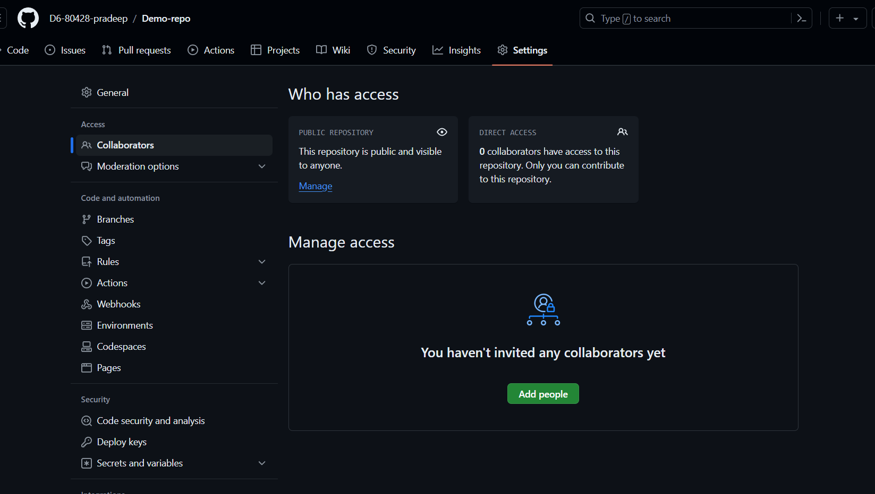



**6. Collaboration in Private Repositories:**

* **Teamwork Makes the Dream Work:** With collaborators, you can work on the same codebase simultaneously. Utilize features like branches and pull requests to manage changes effectively.
* **Communication is Key:** Communicate clearly with your collaborators to avoid conflicts and ensure everyone's on the same page.

**7. Owner vs. Collaborator Rights:**

* **Owner's Control:** The owner of a repository has full control over its settings, collaborators, and code. They can add/remove collaborators, edit files, manage branches, and delete the repository.
* **Collaborator Permissions:** Collaborators can have varying levels of access depending on what the owner grants them. Typical permissions include read (viewing code), write (editing code), and admin (managing branches, collaborators, etc.).

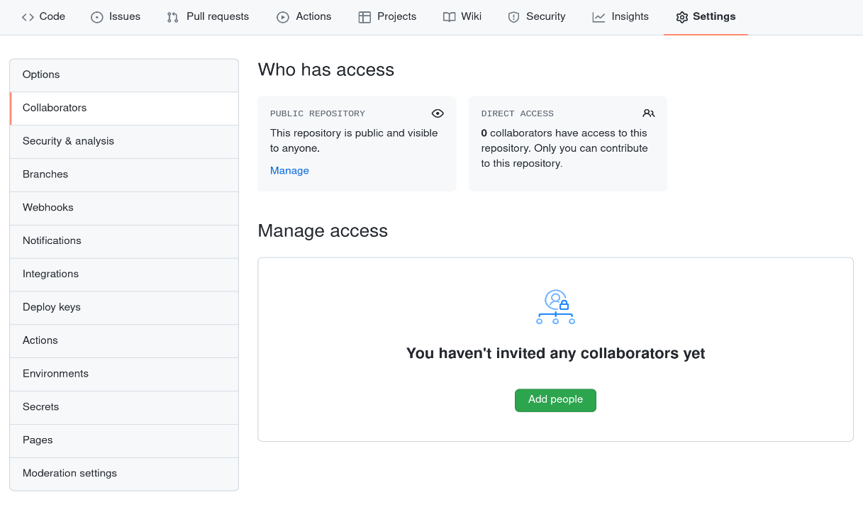

**8. Limiting Interactions (Blocking Users):**

* **Maintaining a Safe Environment:** If someone is harassing you or disrupting your work on GitHub, you can block them. This prevents them from following you, commenting on your repositories, or sending you messages.
* **Blocking Process:** You can typically block users from their profile page on GitHub.

**9. Introducing Organizations:**

* **Teams Made Easy:** Organizations allow multiple users to collaborate on projects under a single umbrella. This is useful for companies, open-source projects, or any group working on multiple repositories.
* **Creating an Organization:** To create an organization, you'll need a paid GitHub account. You can then invite other users to join your organization and grant them appropriate permissions.

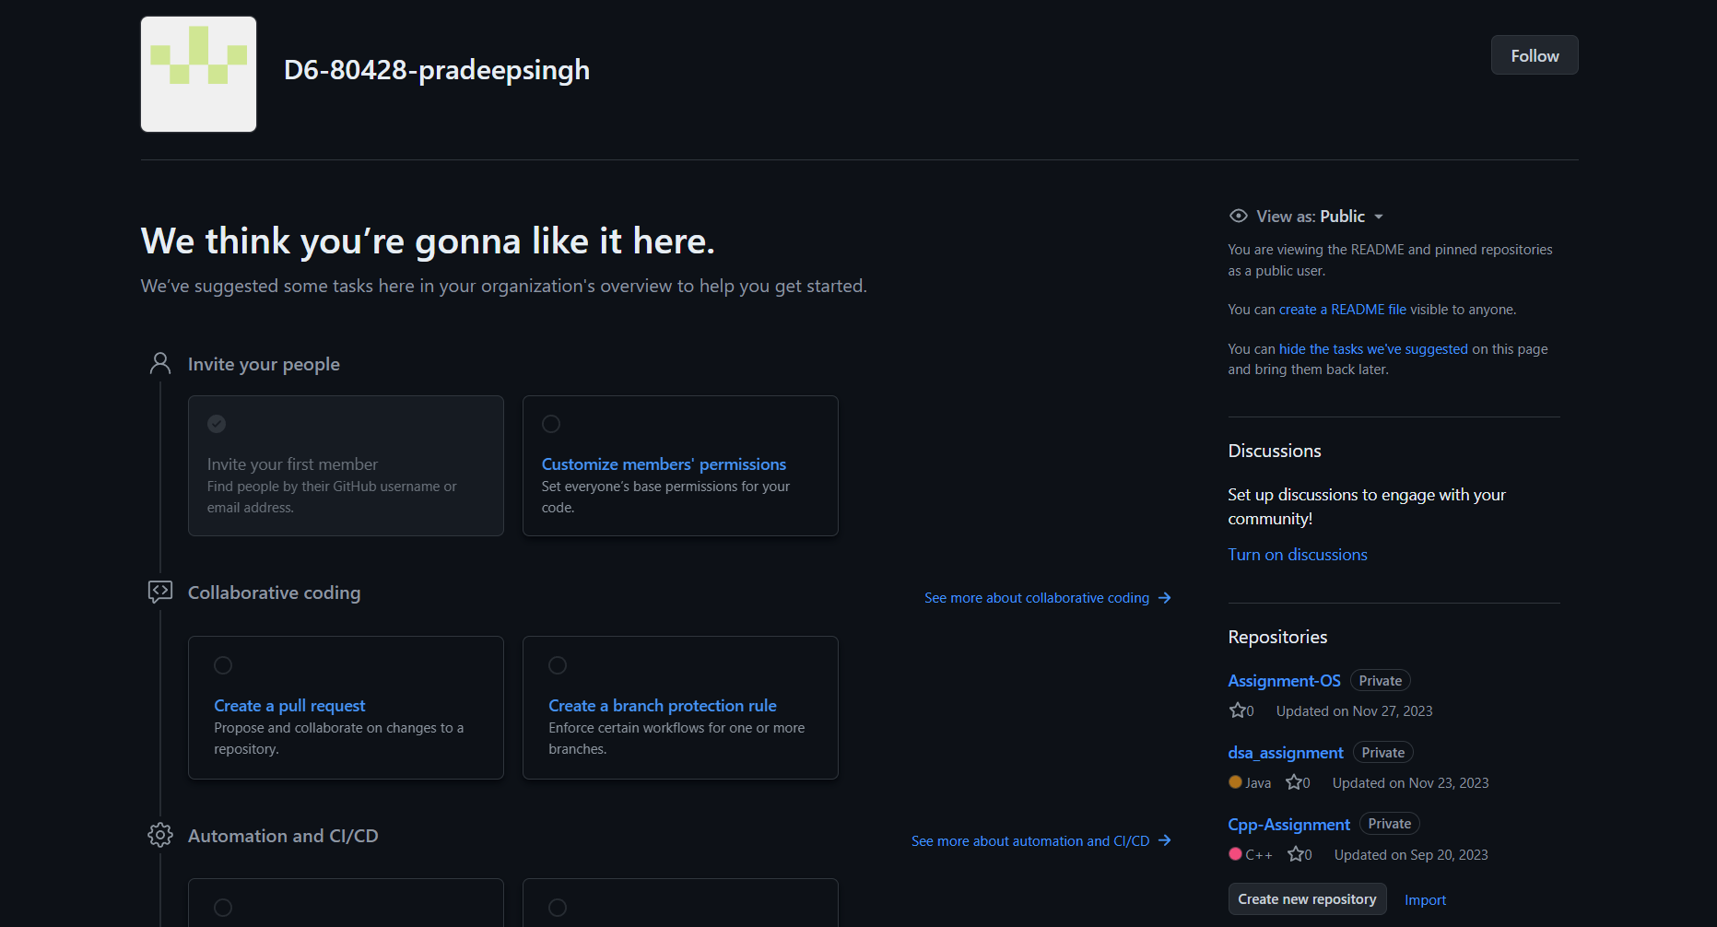

Organization



repositories



**10. Member Repository Permissions:**

* **Controlling Access Within Organizations:** An organization owner can define different permission levels for members, such as allowing them to view and clone all repositories, contribute to specific repositories, or have administrative rights.
* **Managing Permissions:** Organizations provide granular control over who can access and modify repositories within the group.

**11. Adding Outside Collaborators (Organizations):**

* **Bringing in External Help:** Organizations can invite users who aren't members to collaborate on specific repositories. This allows external developers to contribute without joining the organization.
* **Guest Permissions:** Guest collaborators typically have limited access compared to organization members. They might only be able to view and edit code within the specific repository they're invited to.

**12. Adding Organization Members:**

* **Expanding Your Team:** Organization owners can invite new users to join the organization itself. This grants them access to all repositories and features based on their assigned permission level.

**13.Efficient Team Repository Access Management**

**Challenges:** As your team grows and manages multiple repositories, manually assigning access for each member can become tedious. Here's how GitHub helps:

* **Teams:** Create teams within your organization and assign them specific repository permissions. This reduces repetitive tasks of assigning access for individual members.
* **Permissions Sets:** Define different permission sets (e.g., "read-only," "contributor," "admin") and assign them to teams or individual members. This allows granular control over access levels.

**14.Forks and Pull Requests: Collaboration Workflow**

**1. Forking a Repository:**

* **Making a Copy:** A fork is a personal copy of a repository on your GitHub account. It allows you to make changes without affecting the original repository.
* **Forking for Collaboration:** When working on a team project, you can fork the main repository, make your changes on your fork, and then submit a pull request for review and integration.

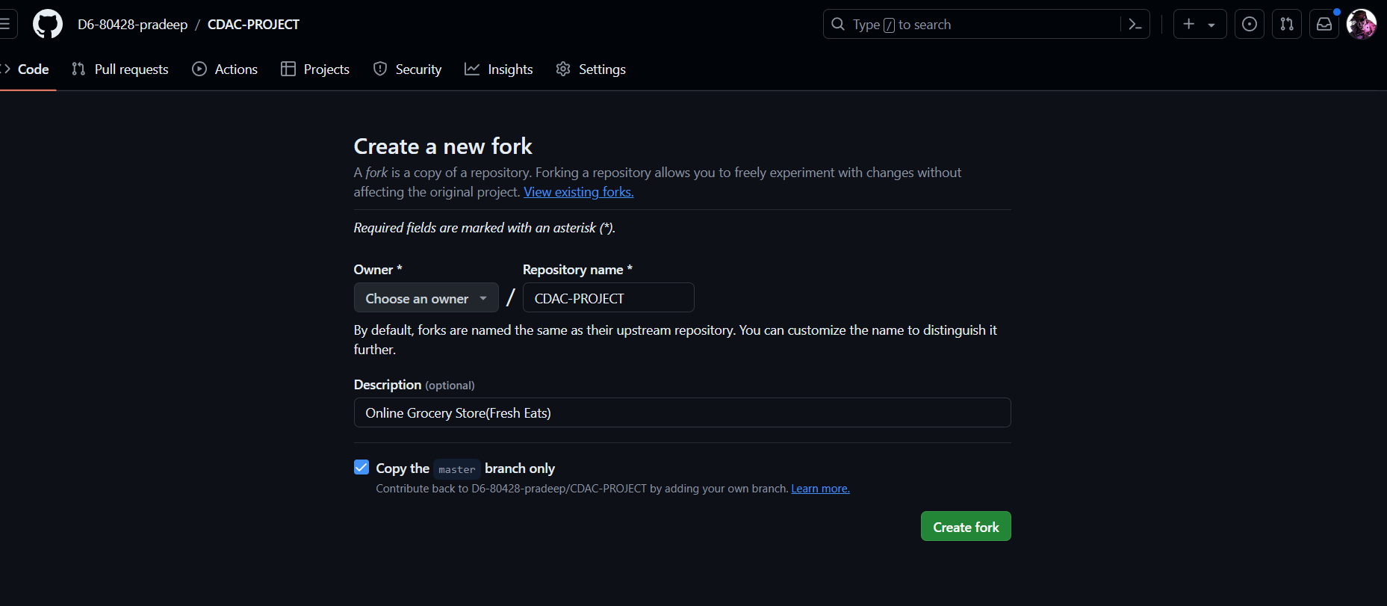



**15. Pull Requests in Action:**

* **Sharing Your Work:** A pull request is a way to propose changes from your forked repository back into the original repository. It allows the owner (or collaborators) to review your changes before merging them.
* **Collaboration and Review:** Through pull requests, team members can review each other's code, discuss changes, and suggest improvements before integrating them into the main codebase.

**16.Raising Issues and Tracking Progress**

**Opening & Closing Issues:**

* **Identifying Problems:** An issue is a way to report a bug, request a new feature, or ask a question about a repository.
* **Tracking and Resolution:** You can open issues on a repository, assign them to team members, and track their progress towards resolution. Closing issues indicates they've been addressed.

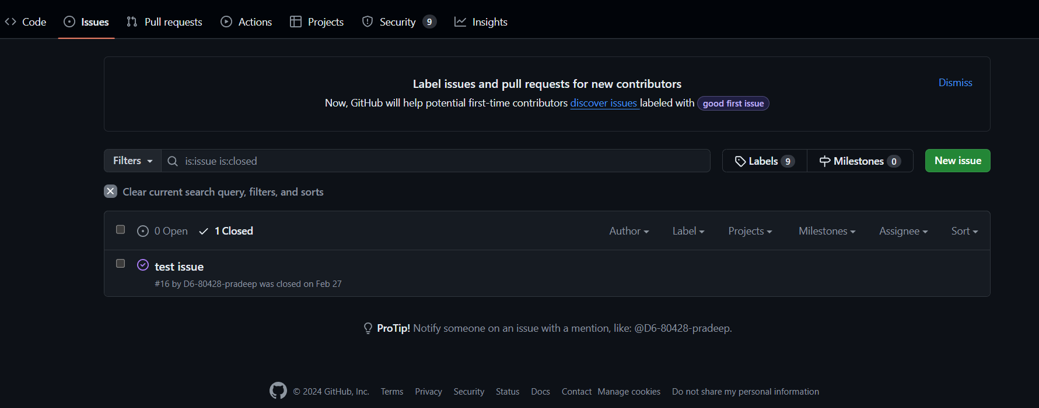



**17.Organizing Work with GitHub Projects**

* **Managing Tasks:** Projects offer a visual way to organize your work within a repository. You can create boards, add cards for tasks, and categorize them based on status (e.g., "to do," "in progress," "done").
* **Enhanced Collaboration:** Projects provide a collaborative environment for teams to track progress, assign tasks, and stay on the same page.

**18.The Importance of a README File**

* **Project Introduction:** A README file is a plain text file located in the root directory of your repository. It serves as the first point of reference for anyone looking at your project.
* **Providing Context:** A good README typically includes information like project description, installation instructions, usage examples, and
* contribution guidelines. This helps others understand your project's purpose and how to get involved.

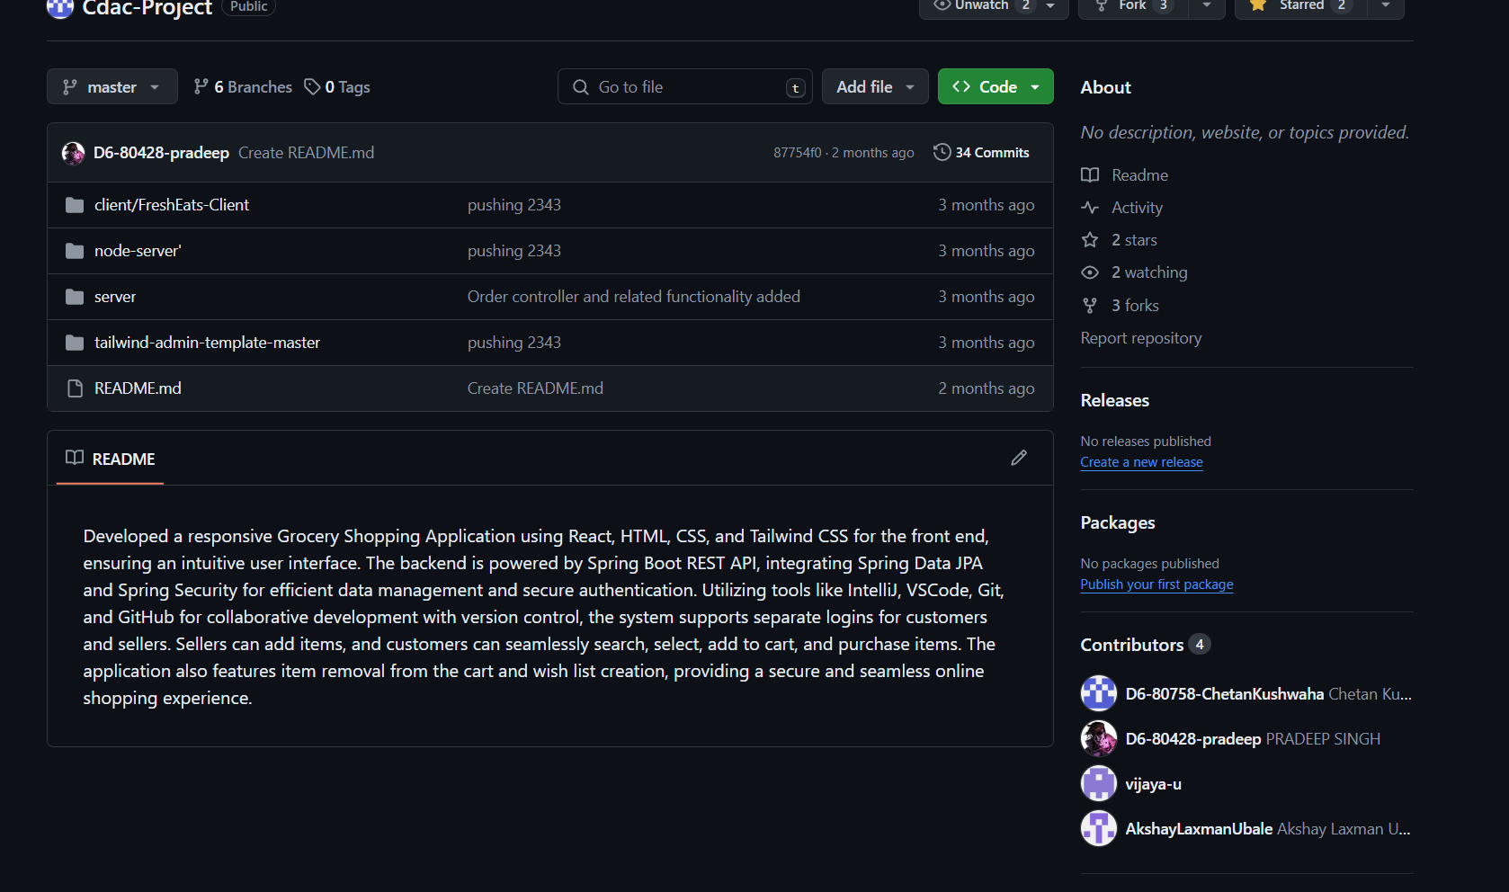



**Preparing Your Project for Contribution on GitHub**

Let's explore the steps involved in contributing to a project on GitHub:

**1. Project Setup:**

* **Get the Code:** Start by obtaining the project's code. You can either download a ZIP file or clone the remote repository using git clone <remote_url>. This creates a local copy of the project on your machine.
* **Set Up Your Local Environment:** Install any necessary dependencies or tools required to run the project. Refer to the project's documentation for specific instructions.

**2. Creating Your First Local Commit:**

* **Making Changes:** Edit the code files as needed. Use your favorite code editor and make meaningful changes to improve or add features.
* **Staging Your Changes:** Use the git add <filename> command to tell Git which specific file changes you want to include in your next commit. You can also use git add . to stage all modified files.
* **Committing Your Work:** Use the git commit -m "<message>" command to create a snapshot of your changes. Replace <message> with a descriptive message summarizing your modifications. This helps others understand what you've changed.

**3. Pushing Your Code (Initial Push):**

* **Contributing to the Remote Repository:** Once you're happy with your local changes and commit, it's time to share them. Use the git push origin <branch_name> command to push your local commit(s) to the remote repository. <branch_name> is usually master for the main codebase, but it can vary by project.

**4. Cloning the Project (Collaborator's Perspective):**

* **Getting Started as a Collaborator:** If you've been invited to collaborate on a project, you'll need to clone the remote repository using git clone <remote_url>. This creates a local copy on your machine where you can make changes.

**5. Making Code Changes (Collaborator):**

* **Contributing Your Work:** Edit the code files in your local copy as instructed. Make sure your changes don't conflict with any recent updates from other contributors.

**6. Pushing Your Commit (Why it Fails):**

* **Direct Push Might Fail:** Since you're working on a copy of the remote repository (a clone), directly pushing your changes might fail if the original codebase has been updated in the meantime. This is to prevent conflicts between different versions.

**7. Adding a Collaborator (Project Owner):**

* **Granting Access:** If you're the project owner and want to allow someone to contribute, navigate to your repository's settings on GitHub. Look for the "Collaborators" section and invite them by entering their username.

**8. Creating a Personal Access Token (Collaborator):**

* **Secure Authentication:** To push your changes without revealing your password, generate a personal access token (PAT) from your GitHub account settings. Grant it the "repo" permission for basic repository access.

**9. Pushing Successfully (Collaborator):**

* **Pushing with a PAT:** Now that you have a PAT, use the git push origin <branch_name> command again, but this time include your username and PAT: git push origin <branch_name> --set-upstream origin -u <username>:<PAT>. This pushes your changes and configures your local branch to track the remote branch.

**10. Merging the Owner's Branches (Project Owner):**

* **Integrating Collaborator's Work:** Once you receive a collaborator's pull request (explained later), you can review their changes and decide whether to merge them into your main codebase (usually the master branch). Merging combines their contribution with your existing code.

**11. Fixing Merge Conflicts (Project Owner/Collaborator):**

* **Resolving Conflicts:** Occasionally, merging code from different contributors might lead to conflicts, where the same lines of code have been modified in both versions. You'll need to manually edit the code to resolve these conflicts before merging successfully.

**12. Accessing Code via Forks (Alternative Workflow):**

* **Forking for Collaboration:** Another way to contribute is by forking the repository. This creates a personal copy on your account. You can make changes on your fork and then submit a pull request to propose merging your changes into the original repository.

**13. Contributing to the Project (General):**

* **Writing Good Code:** Make sure your code contributions are well-structured, follow the project's coding style guidelines (if any), and include clear comments explaining your changes.

**14. Creating a Pull Request: Proposing Changes: After you've pushed your local commits (including with a PAT), create a pull request on GitHub. This notifies the project owner**

* **Proposing Changes:** After you've pushed your local commits (including with a PAT), create a pull request on GitHub. This notifies the project owner